2014-SI-01-EN Through the Maze
0 ---- | I: ---- | II: medium | III: easy | IV: easy

Answer Type: Multiple Choice Mandatory for: none

Body

Last year, there was a competition in which the beavers had to retrieve a treasure from a maze using a robot. There was only a single path leading to the chest. The robot was very fragile, so they had to be careful not to hit any walls.

This year they must repeat the endeavor, but a hungry young beaver ate most of the map! This is all that remained.
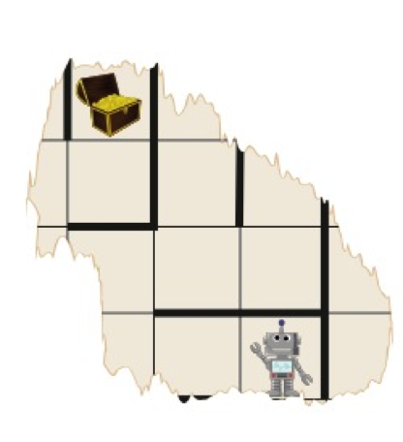

Question

Last year, they used one of the following paths to guide the robot to the treasure chest and back, but they forgot which one. Help them!

Answer

A. LLURUURULLLDDRUDLUURRRDLDDLDRR
B. LLURULURULLDDRUDLUURRDRLDDLDRR
C. LLURUURULLLLDRUDLURRRRDLDDLDRR
D. LLLLLULUURDRURRRLDLULDDRURRRRL

Explanation

The correct answer is A; for all others we can find a reason why they must be wrong.

Answer B is wrong. The path must lead to the chest and then back using the same path. It must thus be symmetric: from the chest on, it must repeat itself in reverse, with L and R, and with D and U swapped. In answer B, the second half does not follow the same path backwards.

Answer C does not lead to the chest at all, which we can discover by following the path; we can imagine the part of the map that is missing and assuming that it does not hit any walls.

Answer D approaches the chest from the left, which is impossible.

It's informatics

When a program fails, programmers must find the errors by either tracing its execution, as we did for answers C and D, or by finding more clever ways of discovering what may be going wrong, like for answer B, where we discovered that the program is not symmetric in the way it ought to be.

Keywords

Programming, Debugging

Websites

((too basic to have any specific web sites))

Internal Use

Wording

Comments

Janez Demšar, janez.demsar@fri.uni-lj.si (2014-04-27): Do not remove the sentence about the robot fragility, lest somebody could believe that commands that cannot be carried out may be ignored and skipped.

Graphics

https://openclipart.org/detail/174781/mustache-bot-by-ruthirsty-174781
https://openclipart.org/detail/122029/treasure-chest-by-dear_theophilus

Images from Openclipart are licensed for unlimited commercial use (https://openclipart.org/share).

Files

2014-SI-01-EN Through the Maze.odt (this file)
2014-SI-01-EN Maze.svg

Authorship

Janez Demšar, janez.demsar@fri.uni-lj.si, Slovenia
Inspired by 2013-SI-12 (Iztok Ostrožnik)

License

Copyright © 2014 Bebras – International Contest on Informatics and Computer Fluency. This work is licensed under a Creative Commons Attribution-NonCommercial-ShareAlike 3.0 Unported License (CC BY-NC-SA 3.0). Visit: http://creativecommons.org/licenses/by-nc-sa/3.0/

